

Looking for what to do?
Some Ideas to Stop Authoritarianism

Maybe you’re wondering, “What should I do in these times?” What we have put down here are some meaningful places to start — doable, local, impactful, and important.

It is not intended to be inclusive of all options — we’re trying to offer places we see people making impacts and avenues that as experienced organizers thinking about these times we see as worth going down.

Where possible, we offer names of groups who are organizing such things and can help you plug in to their strategy.

No matter where you come from, here are some ideas if you want to help stand for a world with tolerance and love, racial justice and acceptance of all people.

If you have additional ideas to add, please suggest them to info@disruptionproject.org.

Want occasional updates on email about ways to act in these times? Sign-up here.

How to use this document
Protect People
EASIER TO DO
Defend Civic Institutions
Disrupt and Disobey
Build alternatives

How to use this document
This should be pretty simple.

- Find a path that speaks to you.

We’re following Daniel Hunter’s categorization from 10 ways to be prepared and grounded now that Trump has won:
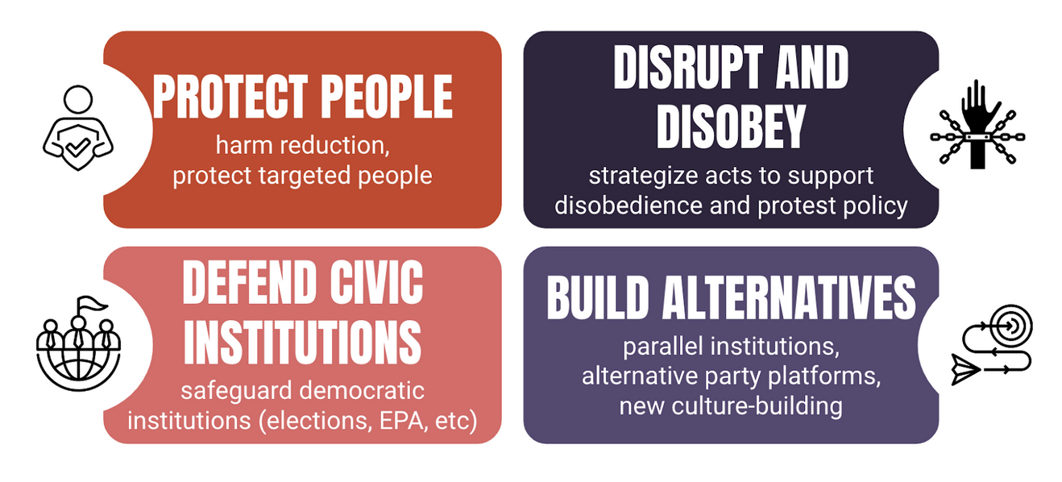
- Protecting People. These are folks surviving and protecting our own — especially those of us directly targeted, such as trans people, folks in need of abortions, and immigrants.
- Defending Civic Institutions. This group may or may not be conscious that current institutions don’t serve us all, but they are united in understanding that an autocrat wants them to crumble so they can exert greater control over our lives.
- Disrupting and Disobeying. This goes beyond protesting for better policies and into the territory of people intervening to stop bad policies or showing resistance.
- Building Alternatives. We can’t just be stuck reacting and stopping the bad. We have to have a vision. This is the slow growth work of building alternative ways that are more democratic.

- Pick your degree of difficulty.
Pick based on how much challenge you’re up for given your skills, time, and life circumstances. Easy actions can typically be done alone and with less time, while we’ve categorized harder actions as those that require more time, people skills, and often a small group to launch with.

- Connect with a group (if applicable).
Whenever possible, we’ve tried to identify groups that can plug you in. Because of this being a big broad list, it’s often national groups — but we prefer you connect with local groups wherever possible.

- Do it!
And let us and the world know your success stories! (You can email us at info@disruptionproject.org.)

Protecting People
Autocrats don’t want us standing up for each other. An easy step to disobey that is sending signals into your community that you care — that you will publicly stand with targeted communities. Here are some examples:

EASIER TO DO
Partner with a local pride group to ask local businesses to put up a sign acknowledging that all folks are welcome in their stores. The “Welcoming Project” provides free signs and FAQ resources to encourage businesses, health care/service providers, organizations, and congregations to display welcoming signs.

Make sure every location you go to has a sign that says all people are welcome here (such as this work from artist Favianna Rodriguez). Shop somewhere, ask them. Workshop somewhere, ask them, kids go to little league somewhere, ask them.

MEDIUM TO DO
Partner with a hospital or clinic to start an abortion-support fund, for folks seeking out-of-state medical care. You can find a local abortion-support fund to support/create on the national map hosted by the National Network of Abortion Funds.

Build a bi-partisan coalition to research, expose, and educate the community about white nationalist threats. Examples: Idaho Leaders United calls out extremist ‘culture of permission’

Get your school board, city council, hospital commission or any government agency to affirm that they are a welcoming community to all people. For example, you can get your community to explicitly welcome and celebrate immigrants in the community joining the 300+ communities welcoming immigrants with the “Welcoming Network”.

Get your religious group, school, or little league to make a resolution in support of targeted folks. For example: why vaccinations are good practice or why everyone deserves to play sports, regardless what gender was assigned at birth. Faith institutions could stretch the limits and see if police departments or local officials are willing to inform them in advance what community members might be in danger of being snatched for deportation, so they can move to protect them.

HARDER TO DO
Train volunteers in your city and state on basic safety skills that could be used as white nationalist violence ramps up. Training support on action safety: Action Security and De-escalation with links at the end for further training.

Start recruiting a slate of pro-democracy candidates for City Council or School Board. Run, support, or get involved by connecting with Run for Something.

Campaign against book bans in your state or town — even before they are proposed. Join Pen America’s Book Bans campaign.

Defending Civic Institutions
Autocrats love weak institutions — because they can twist them to their personal goals. Institutional ethics, values, and bureaucracy can all be used to resist those efforts. We may often think of federal institutions (like the military), but a lot of these institutions are very local: health commissioners, local scientists, schools, election officials. We can seek to defend local civic institutions, particularly when they are doing their job and refusing to engage in immoral or unsavory acts.

EASIER TO DO
As a veteran, connect with other groups who are resisting politicizing the military. Join Secure Families or National Security Leaders for America.

For Civil Servants, download and read “Serve the People: A civil servant’s guide to 2024 and beyond.” Learn strategies for what to do in the future. (And connect with the folks at Civil Service Strong.)

Send supportive letters to people who run our elections, who are facing increasing hatred, bile, and even death threats. Send a letter with Protect Our Elections.

MEDIUM TO DO
Start a citizen campaign practicing random acts of support. For example, order food for over-staffed nurses, blanket yards with signs supporting county health commissioners, or actively give out thank you cards with tips to front-line workers who are protecting us.

HARDER TO DO
Collect a list of lawyers who will pro bono support for first amendment protestors ahead of crackdowns. Communicate these lists to local activists.

Create or support a bail fund for local activists when political repression comes. Here is a link to existing bail funds.

Disrupting and Disobeying
Autocrats rely on people “obeying in advance,” meaning anticipating a more restrictive version of society and behaving accordingly. This shows those in power how far they can go, and it moves the needle of what’s “normal” that much more quickly. Disrupting and disobeying the status quo diverts the autocrat’s resources and puts them on the defense instead of allowing them to plow ahead unencumbered. It also signals to others with less courage that they’re not alone in opposing what’s happening and may inspire them to take action.

EASIER TO DO
Build an affinity group. Simply put, get together with a group of people you trust, build some trust together, and start to talk and plan about what risks you are willing to take.

MEDIUM TO DO
As an affinity group, pick a specific issue to work on. We will need you to support migrant rights groups around deportation defense, for example. We might also need you to stop further climate chaos being wrought by fossil fuel companies and their financiers Reach out at info@disruption-project.org to get some coaching on how to take action.

Join with migrant rights groups to join their need for rapid response deportation defense.

Test the boundaries of the law, just a little. Alternatively to a massive sit-in to shut down a plant, you can have each person just cut one chain in the fence — as practice of resistance.

Call the Resistance Hotline (844-NVDA-NOW) to get coached on how to do an action even more powerfully.

HARDER TO DO
Engage in active noncompliance. Noncompliance is taking bold action against a system that you feel is immoral. Noncompliance can be about a larger way of life that says that the whole system is fundamentally broken and that we need mass numbers of people not participating in it. War Resisters for decades have refused to pay taxes, arguing that they just are unwilling to participate in a system that kills people around the world. As documented, authoritarian regimes don’t fall because of protests — they fall because the people refuse to go along with the regime, through mass refusals to pay taxes, mass defections in military and government, or strikes that paralyze parts of the normal functioning of society. Read more on Strategic Escalation in the Trump Era.

Build tax resistance strategies. Responding to the moral crisis of these times, individuals may refuse to pay taxes to an unjust system. Cities and municipalities may refuse to withhold federal taxes — or endorse policies that support tax resistance. The most expertise in tax resistance comes from the anti-war/peace movement: e.g. National War Tax Resistance Coordinating Committee or War Resisters League.

Jail solidarity. There was not a team of lawyers attempting to bail out Gandhi or Martin Luther King, Jr. They were held until they were released. Think about your team the same way. If you are arrested taking action, why would you pay money into a broken system? Why not stay in jail? This is known as jail solidarity. This serves two purposes. First of all, if enough people engage in jail solidarity it becomes a real problem for those in charge. Where do they house everyone? Second, the story of who is in jail can be pretty compelling too. Folks who are in for multiple days have access (or their friends do) to the press and can tell their stories, why they are there and why they are taking huge risks to support immigrants, or fight for the climate.

Wildcat strikes. If you’re in a union, can you organize your union to walk out in a wildcat strike, at a particular key juncture, when some threshold is crossed around worker protections? Or for undocumented folks? Begin those conversations now.

Organize your workplace. If you’re not in a union, can you organize folks in your workplace? To fight back against workplace raids? To stop work if some threshold is breached?

Organize, organize, organize — especially in neglected places. In 2017, many organizers moved from progressive areas back to where they grew up to start organizing projects in their hometowns. We will need more of these. In the section on protecting institutions, we mentioned some civic organizing that needed to happen. But, there is also the need for people to attempt ambitious organizations, whether it is faith institutions in the Quad Cities, Iowa; tenant organizing in Erie, Pennsylvania; or fighting to raise the minimum wage in Waukesha, Wisconsin. We need a lot more of these local organizing projects. While starting a new organizing project is challenging, we’re not going to dispute that, we are also available to talk with people to assess whether they can start something. We think lots of dedicated people can do interesting and important work. And, you don’t have to start all at once, you can also start with some of the suggestions in the first section on protecting people and see if you can gather some people together or win some smaller victories.

Shut things down. We’re happy to discuss details, but so much of what needs to happen is the shutting down of business as usual. Whether this is a strike at the ports or whether we could shut down finance or logistics, or extraction, this is the kind of mass action we need to be thinking about — not just protests.

Building alternatives

EASIER TO DO
Bring community together. Organize a potluck or clothing swap. Get folks together to talk about what they fear or hope in the times ahead. You can see one such agenda at Worth Fighting For.

MEDIUM TO DO
Build a community garden. Make it a community project to grow food and community.

Start a monthly or weekly mutual aid group. Mutual aid is a way to offer a place for exchanging needs in the community. It’s not a charity model but about the community finding its own resources, like offering unsheltered people homes in a church or community center or setting up ways to exchange meals, naloxone, legal help, pet supplies, winter clothing, etc. etc. (Training on mutual aid here: Mutual Aid 101.)

HARDER TO DO
Help build the future we need by developing community solar or renewable power owned by the people. 350 has one such resource at OurOwnPower.org.

Get your city or state to promote participatory budgeting. Participatory budgeting (PB) is a direct democratic process where community members decide how to spend the public budget. It gives people real power — direct ownership over the decisions with full transparency. Learn more from the Participatory Budgeting Project.

Promote policies to abolish the electoral college, support third parties, or otherwise make this country more democratic. This is a big project — but lots of groups are exploring ways to do this. Because there are so many and many of them are nascent, we don’t have recommendations here — but encourage you to research ones that align with your values and organizing instincts.

Liberated territory. The right-wing militia movement in this country has created some liberated territory, whether that lives in their ranches or in the election of “Constitutional Sheriffs” who do not recognize the federal government, they swear an oath to the constitution. Create similar territories of sanctuary and protection, where folks are able to live free lives.

There is a lot of information here, so take a deep breath. There is a Jewish teaching that says that you are not responsible for completing the work, nor are you allowed to desist from it. We will succeed because millions of people do a couple things well, not because one person does a million things.

While we wish we were not compelled to travel down this path of resistance. We are excited to realize the collective beauty we can and will create together.

You got this.

If you have additional ideas to add, please suggest them to info@disruption-project.org.

